EXPERIMENT : 1 Create a simple cloud software application for Property Buying & Rental process (In Chennai city) using any Cloud Service Provider to demonstrate SaaS include the necessary fields such as Buy, Rent, commercial, Rental Agreement , Rental Agreement, Area, place, Range, property value etc.

STEP:1 CREATE A APPLICATION FOR PROPERTY DETAILS.

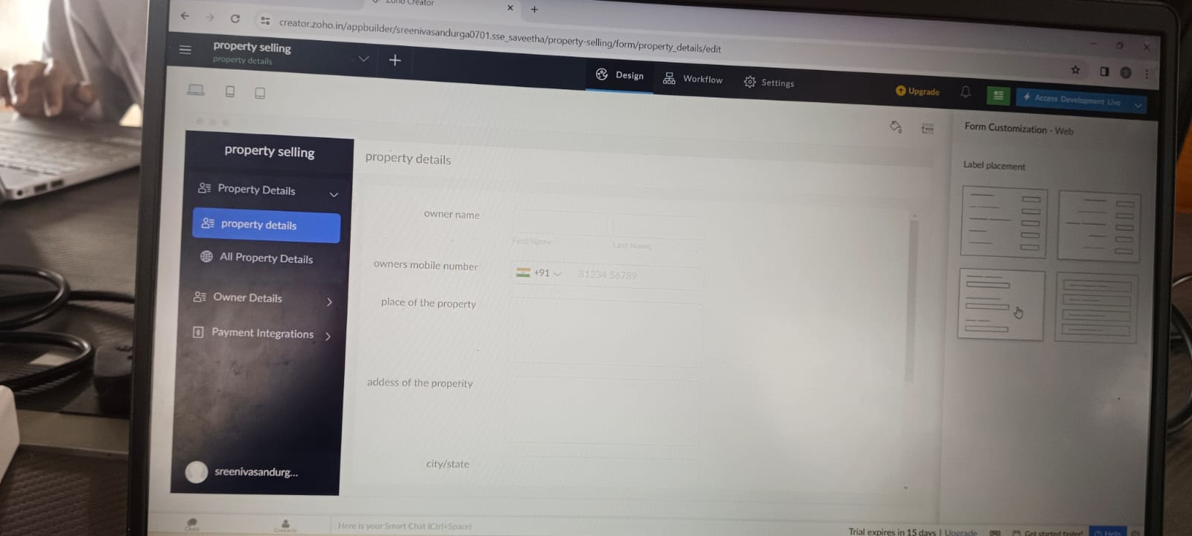

STEP:2 CREATE A APPLICATION FORM FOR OWNER DETAILS.

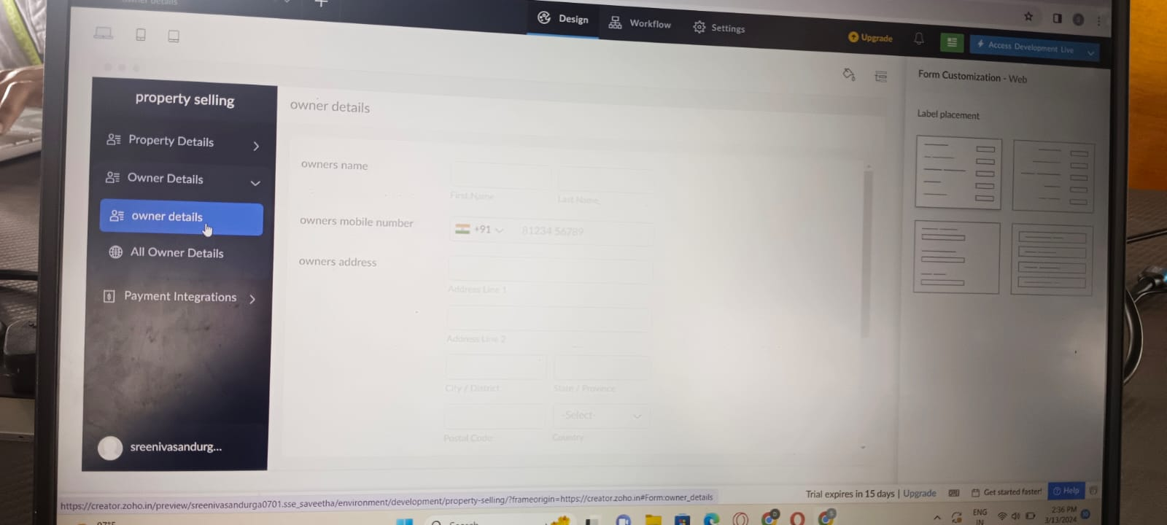

STEP:3 CREATE A APPLICATION FORM FOR PAYMENT INTEGRATION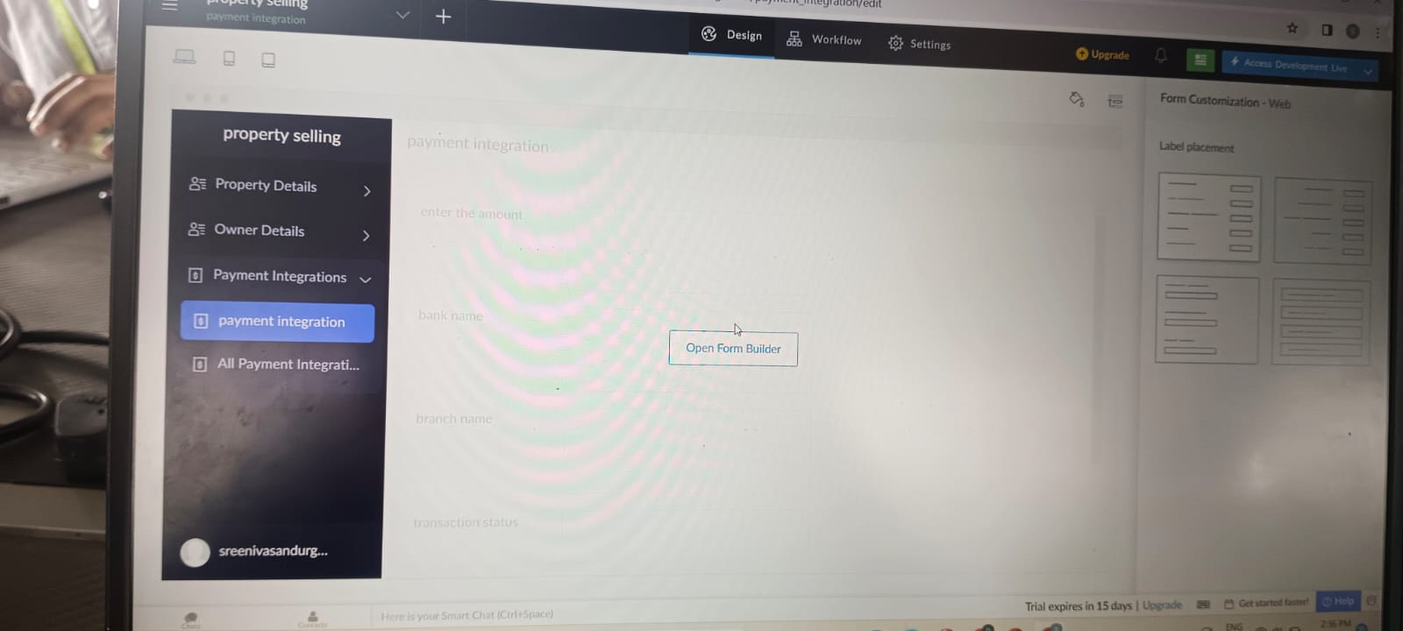

STEP:4 CREATE A APPLICATION FORM FOR PAYMENT INTEGRATION RESULT

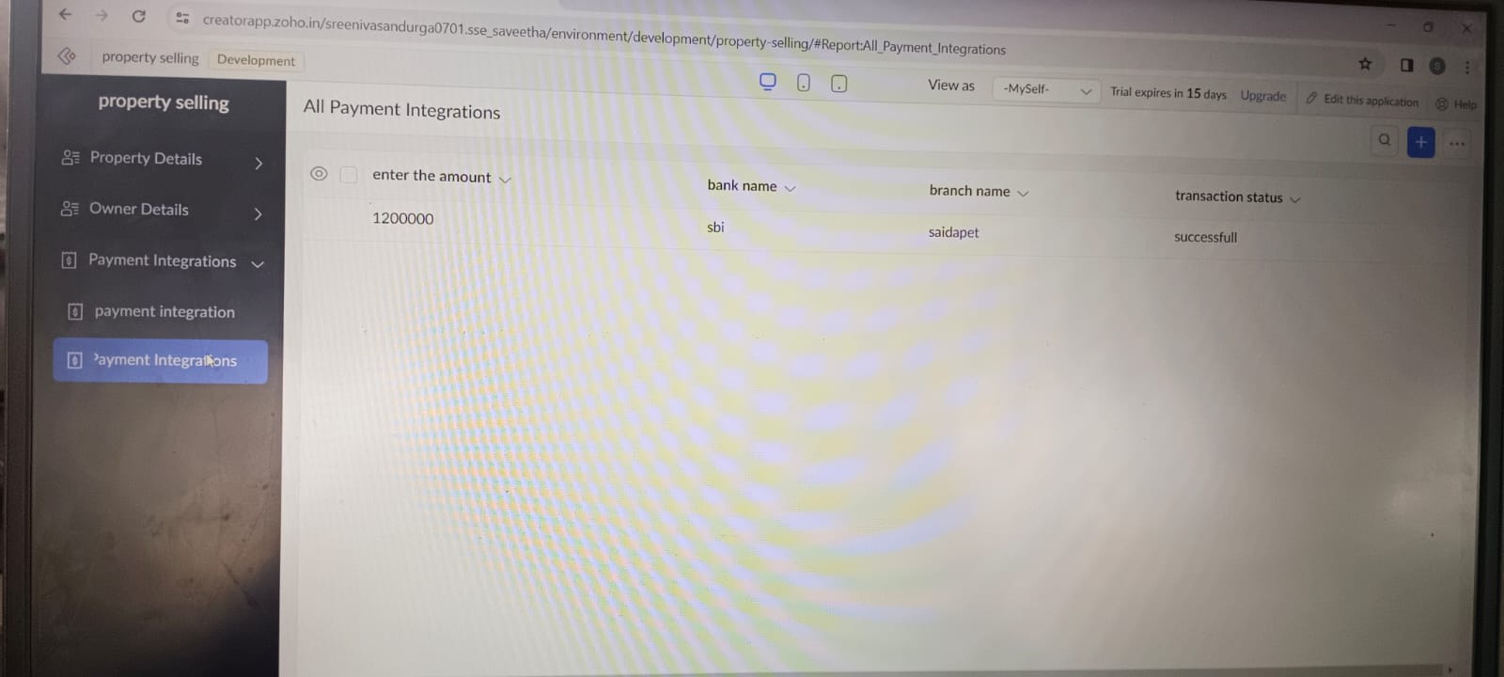

RESULT: THUS , THE PROGARM FOR PROPERITY SELLING HAS BEEN EXCEUTED SUCCESFFULLY .